# SMB Factor - p-value and Coefficient Analysis

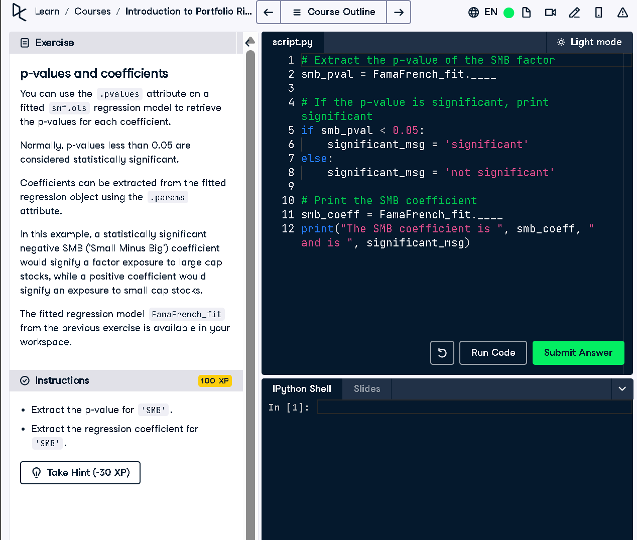

## Python Code

# Extract the p-value of the SMB factor  
smb_pval = FamaFrench_fit.pvalues['SMB']  
  
# If the p-value is significant, print significant  
if smb_pval < 0.05:  
 significant_msg = 'significant'  
else:  
 significant_msg = 'not significant'  
  
# Print the SMB coefficient  
smb_coeff = FamaFrench_fit.params['SMB']  
print("The SMB coefficient is ", smb_coeff, " and is ", significant_msg)

## Explanation (50 words)

This code extracts the p-value and coefficient for the SMB factor from the Fama-French model. If the p-value is below 0.05, the factor is statistically significant. It prints the SMB coefficient value along with whether the result is significant or not, based on the p-value.